Name: Arpit Mahalle

Screenshots of output of react assignment 4 Day 13

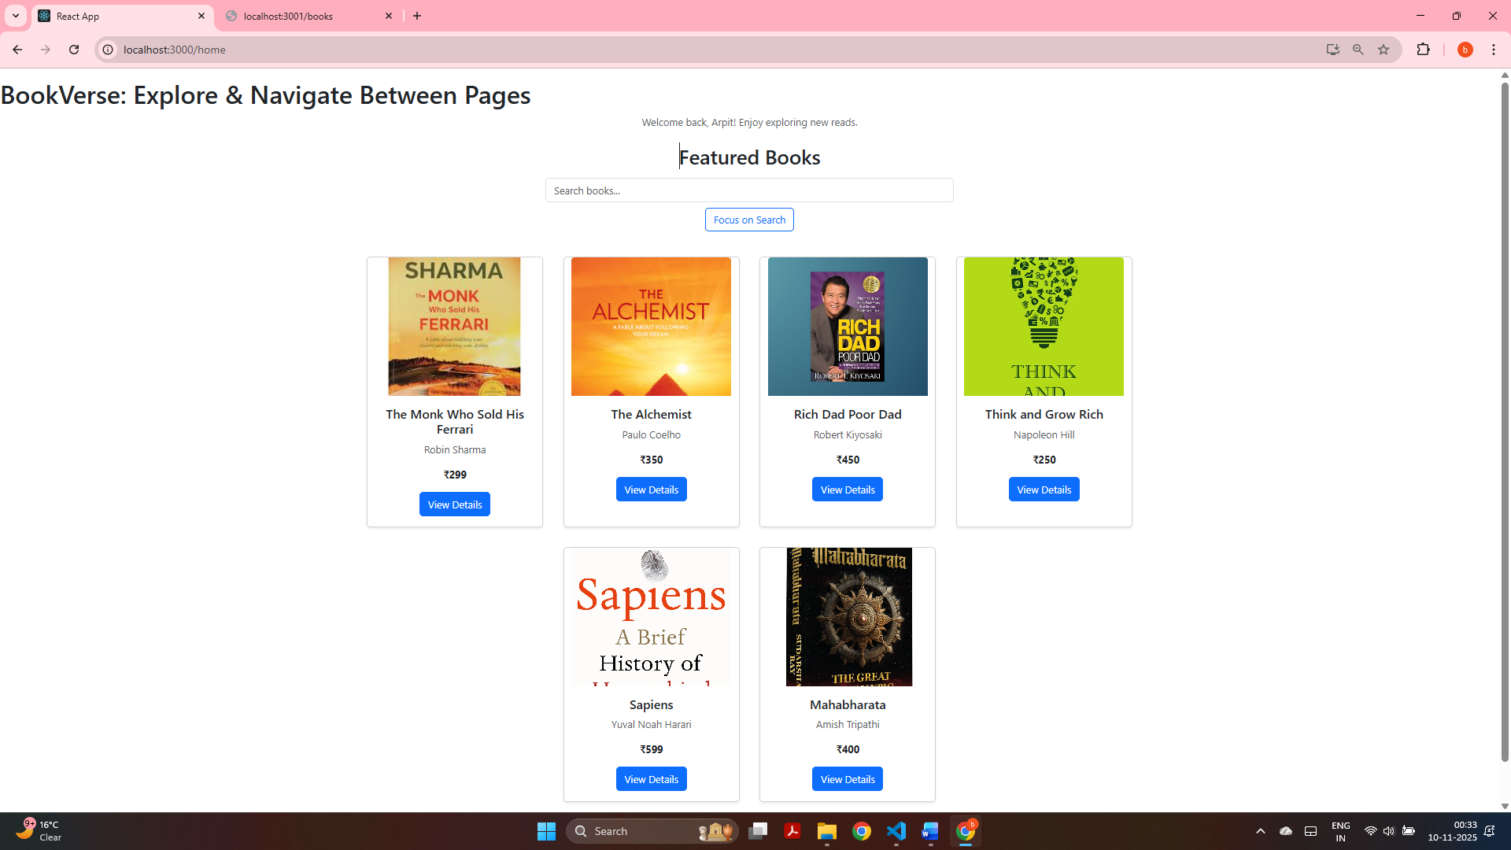
Home page displaying all books, including newly added titles dynamically fetched from the Flux store and backend.

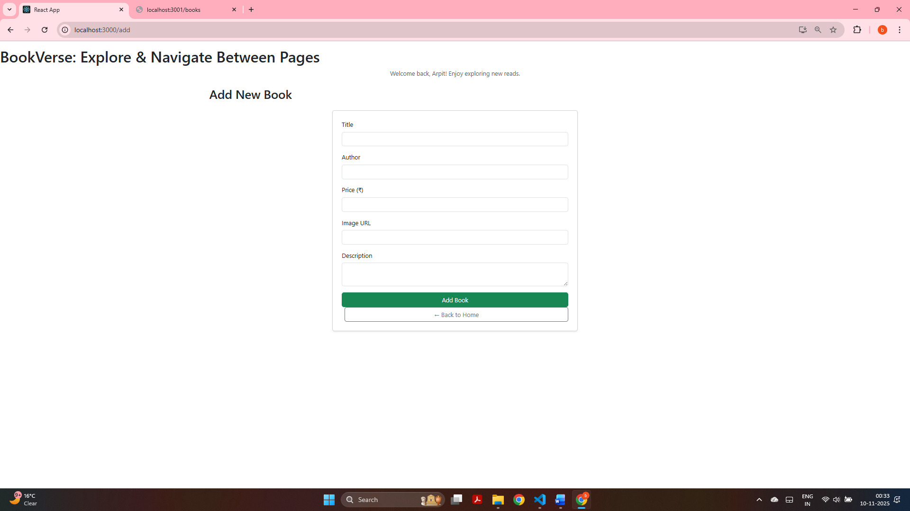
Add New Book page showing a clean Formik form layout ready for book entry with navigation integrated via React Router.

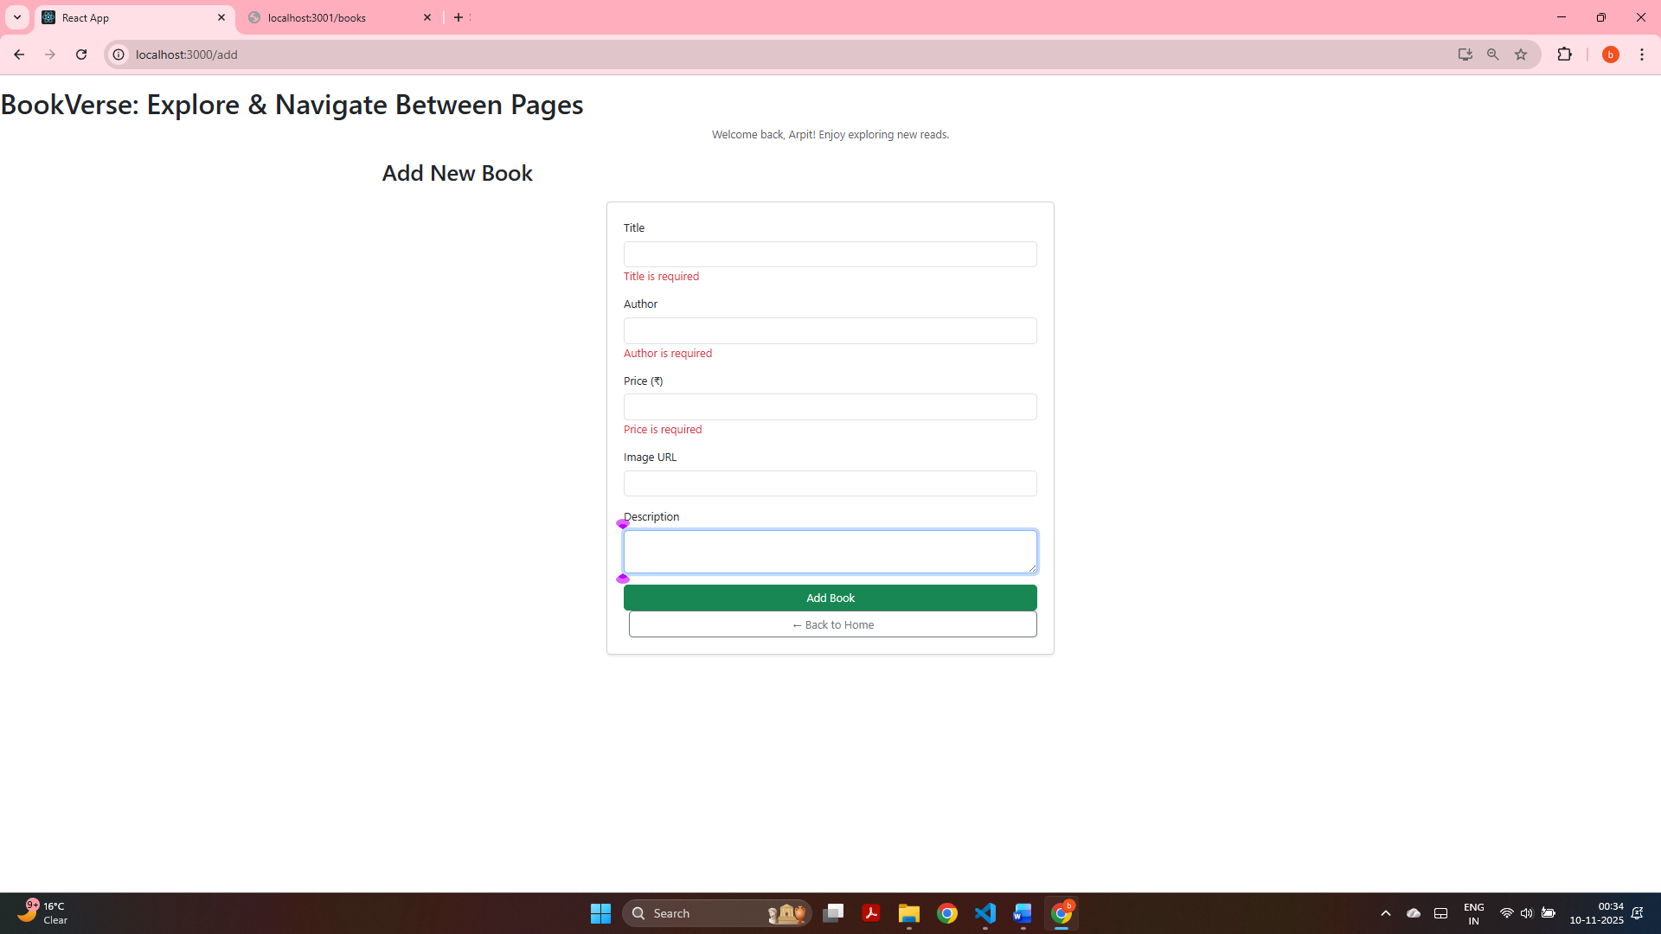
Form validation in action using Yup — showing required field errors when attempting to submit empty fields.

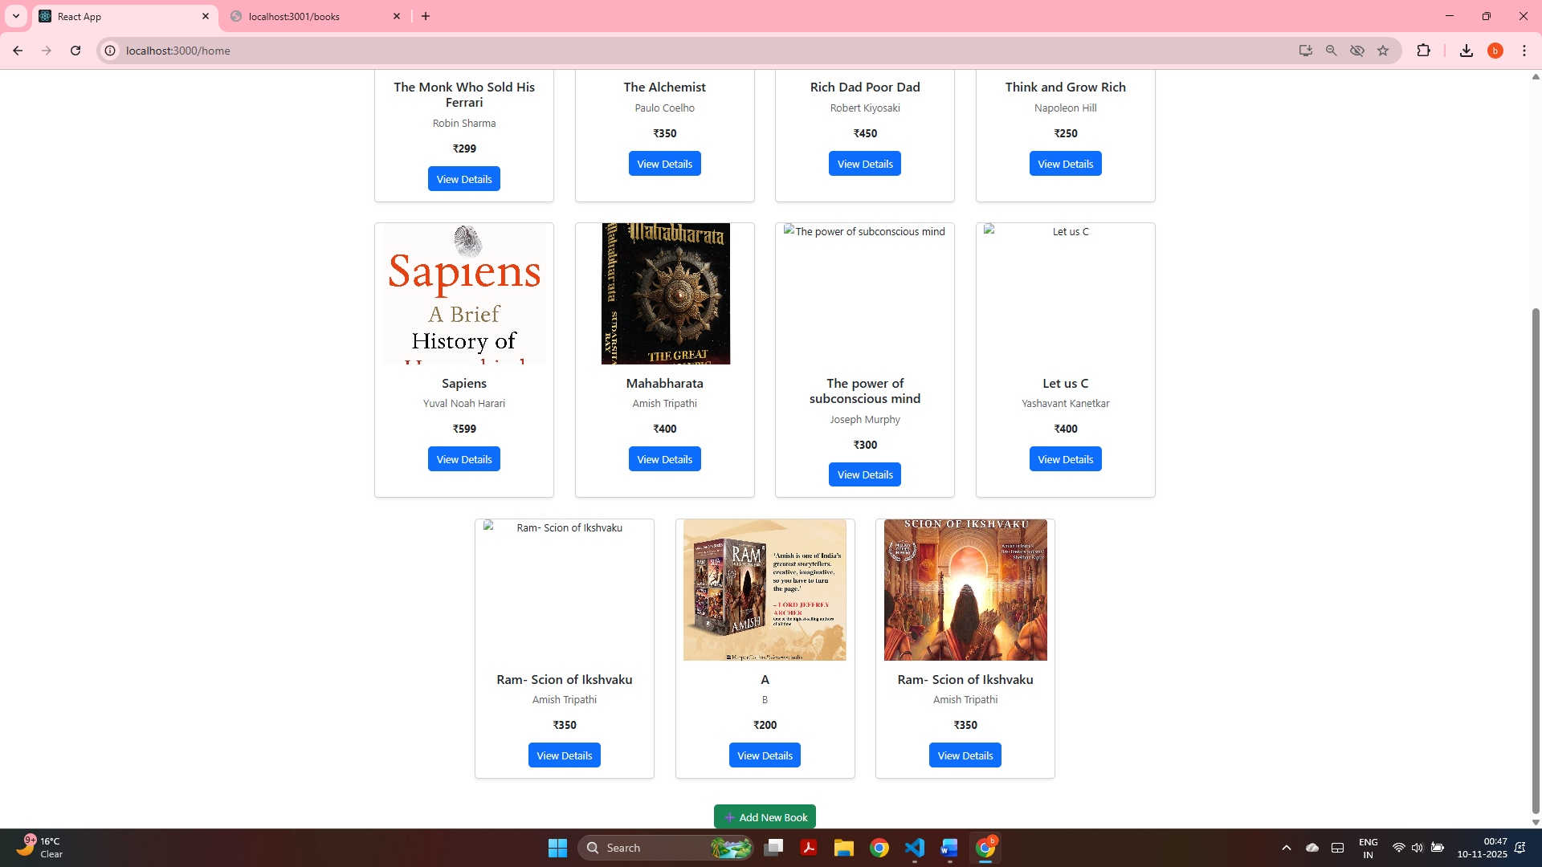
Updated Home page reflecting newly added books instantly, proving live data flow from Formik → Flux Store → View.

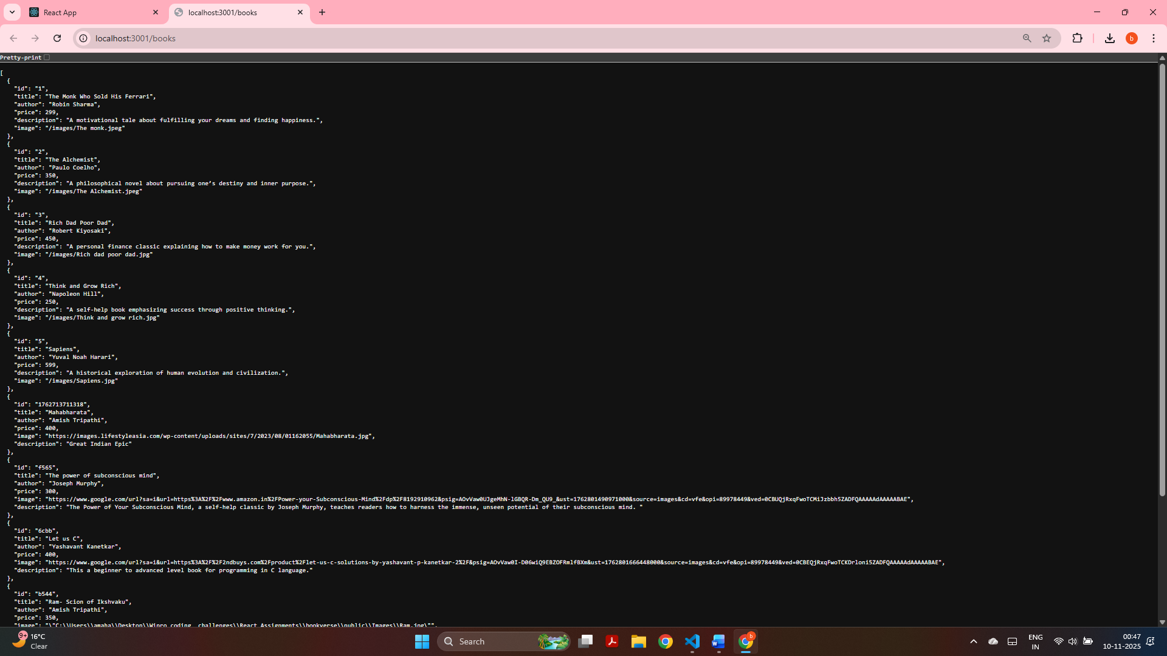
Backend endpoint (http://localhost:3001/books) displaying all book entries including newly added data through the form

